**Space Checkers**

**Version 3.0**

Release Notes

**Prepared by:**

Alan Tsai

Klaus Nuredini

James Swanick

Deepak Yadav

Published: March 12, 2017

Contents

**Introduction to Release Notes**

**Installing Space Checkers**

**Known Issues**

**Introduction to Release Notes**

Welcome to the release notes for Space Checkers version 3.0. Read these release notes thoroughly before you install Space Checkers version 3.0, as they contain information you need to successfully install the game application.

This release supports deployment of the Windows 10 and MacOS 10.11.X.

**Installing Space Checkers**

The Java executable file is provided to run the game. Click on the executable file to run the game.

**Known Issues**

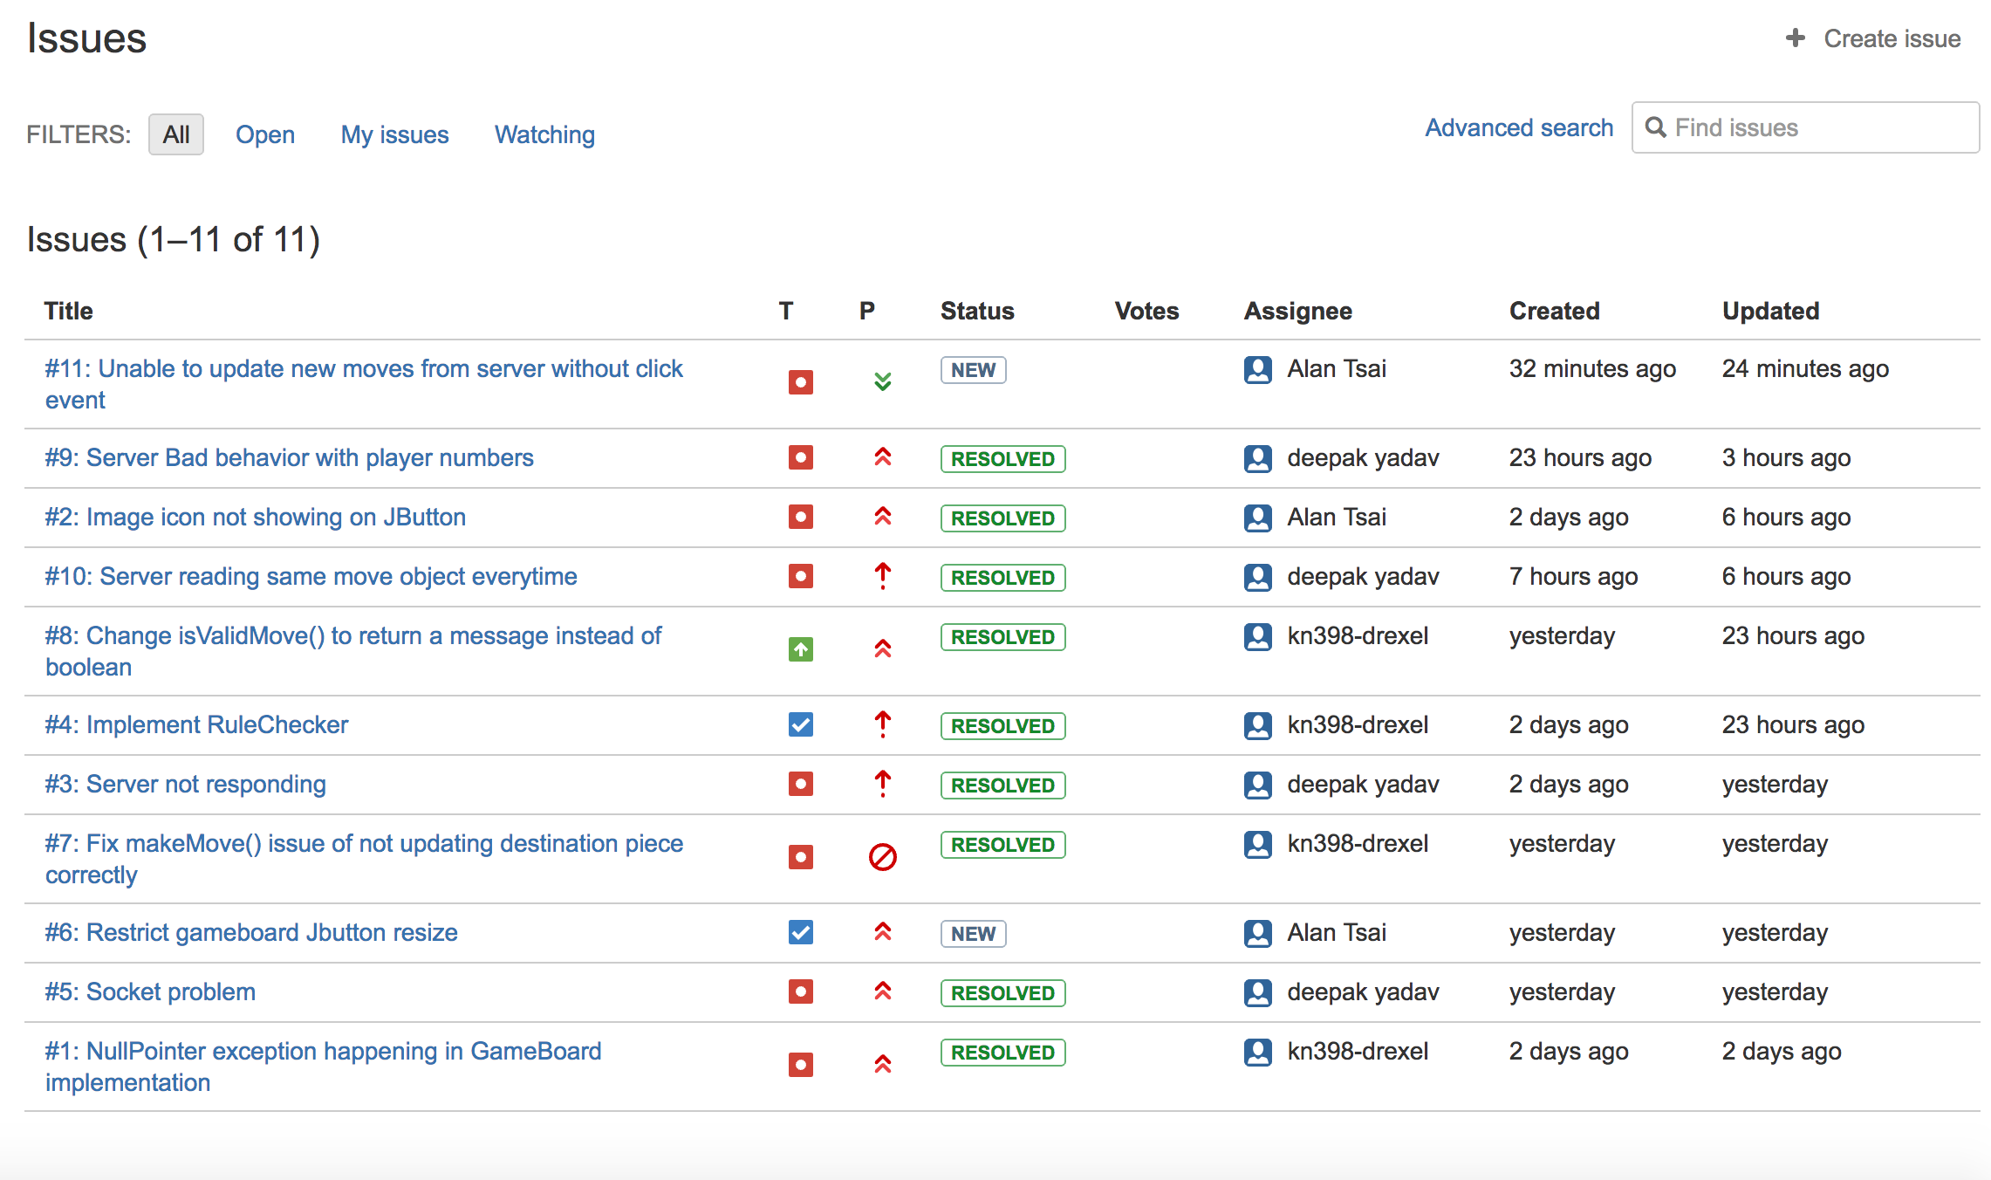

"content": "I removed the thread for only the player who disconnected so that It can assign the thread to new player",  
 "created_on": "2017-03-12T23:28:56.521899+00:00",  
 "user": "dy329-drexel",  
 "updated_on": null,  
 "issue": 9,  
 "id": 35034801  
  
 "content": "Issue has been resolved",  
 "created_on": "2017-03-12T20:14:13.699154+00:00",  
 "user": "ayt32",  
 "updated_on": null,  
 "issue": 2,  
 "id": 35032265  
   
   
 "content": "We discovered that since we sending the same move object reference to server using write its taking the the old value of object. We fixed this problem by resetting the output stream before every write.",  
 "created_on": "2017-03-12T20:11:38.747868+00:00",  
 "user": "dy329-drexel",  
 "updated_on": null,  
 "issue": 10,  
 "id": 35032239

"content": "Fully implemented RuleChecker and resolved Issue #8 & Issue #4; added a\nfew more changes to GameBoard & Piece classes\n\n\u2192 <<cset 13ed0340426c>>",  
 "created_on": "2017-03-12T03:54:02.803270+00:00",  
 "user": "kn398-drexel",  
 "updated_on": null,  
 "issue": 8,  
 "id": 35024823  
  
 "content": "Fully implemented RuleChecker and resolved Issue #8 & Issue #4; added a\nfew more changes to GameBoard & Piece classes\n\n\u2192 <<cset 13ed0340426c>>",  
 "created_on": "2017-03-12T03:54:02.730009+00:00",  
 "user": "kn398-drexel",  
 "updated_on": null,  
 "issue": 4,  
 "id": 35024822

"content": "I freed the the resources allocated for a client So that it can accept new connection once any player disconnects.",  
 "created_on": "2017-03-12T02:26:08.575183+00:00",  
 "user": "dy329-drexel",  
 "updated_on": null,  
 "issue": 3,  
 "id": 35024141

"content": "Resolved Issue #7, implemented part of gameOver(), added helper methods\nto Move and Piece\n\n\u2192 <<cset 96702d380d50>>",  
 "created_on": "2017-03-11T22:30:44.618721+00:00",  
 "user": "kn398-drexel",  
 "updated_on": null,  
 "issue": 7,  
 "id": 35023276

"content": "Fixed issue#5 and added connection helper class with functionality of\nreaading and writing to socket\n\n\u2192 <<cset ff76a1cfd709>>",  
 "created_on": "2017-03-11T21:49:01.242983+00:00",  
 "user": "dy329-drexel",  
 "updated_on": null,  
 "issue": 5,  
 "id": 35023015

"content": "Resolved Issue #1 related to GameBoard\n\n\u2192 <<cset 2ddd7c425068>>",  
 "created_on": "2017-03-11T02:58:52.491962+00:00",  
 "user": "kn398-drexel",  
 "updated_on": null,  
 "issue": 1,  
 "id": 35015189  
  
 "title": "Unable to update new moves from server without click event",  
 "reporter": "dy329-drexel",  
 "component": null,  
 "watchers": [  
 "ayt32",  
 "dy329-drexel"  
 ],

"content": "We have to click any button to get updated move from server .We tried to make it automatic but had some problem so we commented the code for now . work on this issue later",  
 "assignee": "ayt32",  
 "created_on": "2017-03-13T02:28:48.956244+00:00",  
 "version": null,  
 "edited_on": null,  
 "milestone": null,  
 "updated_on": "2017-03-13T02:37:21.562338+00:00",  
 "id": 11  
   
 "status": "resolved",  
 "priority": "major",  
 "kind": "bug",  
 "content_updated_on": null  
 "title": "Server Bad behavior with player numbers",  
 "reporter": "dy329-drexel",  
 "component": null,  
 "watchers": [  
 "dy329-drexel"

"content": "There is a bug where when we connect to server and it assigns player 1 and when we disconnects and connect again It will give player 2. So not giving player 1 again even if its only 1 player.",  
 "assignee": "dy329-drexel",  
 "created_on": "2017-03-12T03:33:30.248591+00:00",  
 "version": null,  
 "edited_on": null,  
 "milestone": null,  
 "updated_on": "2017-03-12T23:28:56.503925+00:00",  
 "id": 9  
   
 "status": "resolved",  
 "priority": "major",  
 "kind": "bug",  
 "content_updated_on": null,  
   
 "title": "Image icon not showing on JButton",  
 "reporter": "ayt32",  
 "component": null,  
 "watchers": [  
 "ayt32"  
 ],  
 "content": "",  
 "assignee": "ayt32",  
 "created_on": "2017-03-11T03:01:41.414112+00:00",  
 "version": null,  
 "edited_on": null,  
 "milestone": null,  
 "updated_on": "2017-03-12T20:14:13.682281+00:00",  
 "id": 2  
 "status": "resolved",  
 "priority": "critical",  
 "kind": "bug",  
 "content_updated_on": null,

"title": "Server reading same move object everytime",  
 "reporter": "dy329-drexel",  
 "component": null,  
 "watchers": [  
 "dy329-drexel"  
 ],  
 "content": "Server is reading same object every time even if we change and send a new move to server.",  
 "assignee": "dy329-drexel",  
 "created_on": "2017-03-12T19:46:58.743974+00:00",  
 "version": null,  
 "edited_on": null,  
 "milestone": null,  
 "updated_on": "2017-03-12T20:11:38.732201+00:00",  
 "id": 10  
  
 "status": "resolved",  
 "priority": "major",  
 "kind": "enhancement",  
 "content_updated_on": null,  
   
 "title": "Change isValidMove() to return a message instead of boolean",  
 "reporter": "kn398-drexel",  
 "component": null,  
 "watchers": [  
 "kn398-drexel"  
 ],

"content": "So that we have a better idea of whether the move is out of limits, if there are jumps that must be done and the move is not a jump etc. It'd be nice to let the user know of the exact problem instead of just saying \"try again\".",  
 "assignee": "kn398-drexel",  
 "created_on": "2017-03-12T01:28:00.208615+00:00",  
 "version": null,  
 "edited_on": null,  
 "milestone": null,  
 "updated_on": "2017-03-12T03:54:02.813117+00:00",  
 "id": 8

"status": "resolved",  
 "priority": "critical",  
 "kind": "task",  
 "content_updated_on": null,  
   
 "title": "Implement RuleChecker",  
 "reporter": "kn398-drexel",  
 "component": null,  
 "watchers": [  
 "kn398-drexel"  
 ],  
 "content": "",  
 "assignee": "kn398-drexel",  
 "created_on": "2017-03-11T03:05:47.332571+00:00",  
 "version": null,  
 "edited_on": null,  
 "milestone": null,  
 "updated_on": "2017-03-12T03:54:02.739357+00:00",  
 "id": 4  
   
 "status": "resolved",  
 "priority": "critical",  
 "kind": "bug",  
 "content_updated_on": null,  
,  
 "title": "Server not responding",  
 "reporter": "dy329-drexel",  
 "component": null,  
 "watchers": [  
 "dy329-drexel"  
 ],  
 "content": "While using multi threaded server It does not respond to client request some time some times it accept connection sometimes it does not.",  
 "assignee": "dy329-drexel",  
 "created_on": "2017-03-11T03:02:01.654501+00:00",  
 "version": null,  
 "edited_on": null,  
 "milestone": null,  
 "updated_on": "2017-03-12T02:26:08.555256+00:00",  
 "id": 3  
  
 "status": "resolved",  
 "priority": "blocker",  
 "kind": "bug",  
 "content_updated_on": null,  
   
 "title": "Fix makeMove() issue of not updating destination piece correctly",  
 "reporter": "kn398-drexel",  
 "component": null,  
 "watchers": [  
 "kn398-drexel"  
 ],  
 "content": "",  
 "assignee": "kn398-drexel",  
 "created_on": "2017-03-11T22:16:02.769950+00:00",  
 "version": null,  
 "edited_on": null,  
 "milestone": null,  
 "updated_on": "2017-03-11T22:30:44.656301+00:00",  
 "id": 7  
  
 "status": "new",  
 "priority": "major",  
 "kind": "task",  
 "content_updated_on": null,  
   
 "title": "Restrict gameboard Jbutton resize",  
 "reporter": "ayt32",  
 "component": null,  
 "watchers": [  
 "ayt32"  
 ],  
 "content": "In order to add the quit, help and chat thread section on the right side of the game board, the window has to be resized without resizing the Jbuttons.",  
 "assignee": "ayt32",  
 "created_on": "2017-03-11T22:02:46.653258+00:00",  
 "version": null,  
 "edited_on": null,  
 "milestone": null,  
 "updated_on": "2017-03-11T22:02:46.653258+00:00",  
 "id": 6  
   
 "status": "resolved",  
 "priority": "major",  
 "kind": "bug",  
 "content_updated_on": null,  
   
 "title": "Socket problem",  
 "reporter": "dy329-drexel",  
 "component": null,  
 "watchers": [  
 "dy329-drexel"  
 ],  
 "content": "We have to pass socket everywhere in order to use and write to server . and it is causing problems since too much exception handling and input and output streams.",  
 "assignee": "dy329-drexel",  
 "created_on": "2017-03-11T21:46:26.551858+00:00",  
 "version": null,  
 "edited_on": null,  
 "milestone": null,  
 "updated_on": "2017-03-11T21:49:01.253338+00:00",  
 "id": 5  
 "status": "resolved",  
 "priority": "major",  
 "kind": "bug",  
 "content_updated_on": null,  
  
 "title": "NullPointer exception happening in GameBoard implementation",  
 "reporter": "kn398-drexel",  
 "component": null,  
 "watchers": [  
 "kn398-drexel"  
 ],  
 "content": "",  
 "assignee": "kn398-drexel",  
 "created_on": "2017-03-11T02:57:33.365327+00:00",  
 "version": null,  
 "edited_on": null,  
 "milestone": null,  
 "updated_on": "2017-03-11T02:58:52.524499+00:00",  
 "id": 1  
  
 "comment": 35024822,  
 "changed_to": "resolved",  
 "field": "status",  
 "created_on": "2017-03-12T03:54:02.784175+00:00",  
 "user": "kn398-drexel",  
 "issue": 4,  
 "changed_from": "new"  
   
 "comment": 35024823,  
 "changed_to": "resolved",  
 "field": "status",  
 "created_on": "2017-03-12T03:54:02.828983+00:00",  
 "user": "kn398-drexel",  
 "issue": 8,  
 "changed_from": "new"  
   
 "comment": 35023276,  
 "changed_to": "resolved",  
 "field": "status",  
 "created_on": "2017-03-11T22:30:44.680170+00:00",  
 "user": "kn398-drexel",  
 "issue": 7,  
 "changed_from": "new"  
   
 "comment": 35024141,  
 "changed_to": "resolved",  
 "field": "status",  
 "created_on": "2017-03-12T02:26:08.579374+00:00",  
 "user": "dy329-drexel",  
 "issue": 3,  
 "changed_from": "new"  
   
 "comment": 35034801,  
 "changed_to": "resolved",  
 "field": "status",  
 "created_on": "2017-03-12T23:28:56.526151+00:00",  
 "user": "dy329-drexel",  
 "issue": 9,  
 "changed_from": "new"  
  
 "comment": 35015189,  
 "changed_to": "resolved",  
 "field": "status",  
 "created_on": "2017-03-11T02:58:52.545974+00:00",  
 "user": "kn398-drexel",  
 "issue": 1,  
 "changed_from": "new"  
  
 "comment": 35036249,  
 "changed_to": "ayt32",  
 "field": "responsible",  
 "created_on": "2017-03-13T02:37:21.595873+00:00",  
 "user": "ayt32",  
 "issue": 11,  
 "changed_from": ""  
   
 "comment": 35032265,  
 "changed_to": "resolved",  
 "field": "status",  
 "created_on": "2017-03-12T20:14:13.703008+00:00",  
 "user": "ayt32",  
 "issue": 2,  
 "changed_from": "new"  
   
 "comment": 35032239,  
 "changed_to": "resolved",  
 "field": "status",  
 "created_on": "2017-03-12T20:11:38.751138+00:00",  
 "user": "dy329-drexel",  
 "issue": 10,  
 "changed_from": "new"  
  
 "comment": 35023015,  
 "changed_to": "resolved",  
 "field": "status",  
 "created_on": "2017-03-11T21:49:01.300804+00:00",  
 "user": "dy329-drexel",  
 "issue": 5,  
 "changed_from": "new"  
   
 "comment": 35015226,  
 "changed_to": "ayt32",  
 "field": "responsible",  
 "created_on": "2017-03-11T03:07:17.036891+00:00",  
 "user": "ayt32",  
 "issue": 2,  
 "changed_from": ""

Notes on bug reporting:

We used a bug reporter plugin for eclipse called FindBugs. As of this release, it has predicted two bugs:

1.

*void helpInit(int startRow, int finishRow, String myColor)*

*{*

*...*

*if ((i + j) % 2 == 1)*



This bug does not apply to our system, because it is checking for oddness in the position of spaces on the board. There are no negative-positioned board spaces, so this bug will never be a problem.

2.

*public void connect(){*

*try {*

*socket_ = new Socket("10.250.111.162", 1900);*

*}*



This bug may be worth addressing in the future. The problem that an instanced object is saving a static variable. So that if multiple instances of the class are running, they will be writing to the same variable. This may not be intended. In our case, however, the class is only ever instanced once, so this bug is non-destructive. It is not good code practice, though, so it will certainly be changed in future iterations.